Σχεσιακό Μοντέλο
Suppliers(Scode, Phone, Vat, Label, City, Street, Number, PostalCode, GeoCode)
Purchases(Tcode, Date, Quantity, Scode, Pcode,)
Products(Pcode, Name, Description, Price, Stock, CategoryCode)
Category(CategoryCode, Description, Title)
OrderInclude(ReferenceCode, Pcode, Quantity)
Orders(ReferenceCode, OrderDate, Shipping, CustCode)
Customers(CustCode, CusName, CusVat, CusPhone, City, Number, PostalCode, Street, GeoCode)
Region(GeoCode, Population, Gname)
SpecialCustomers(CreditLimit, AccBalance, CustCode)
SpecialPayments(CustCode, Time, Date, Amount)

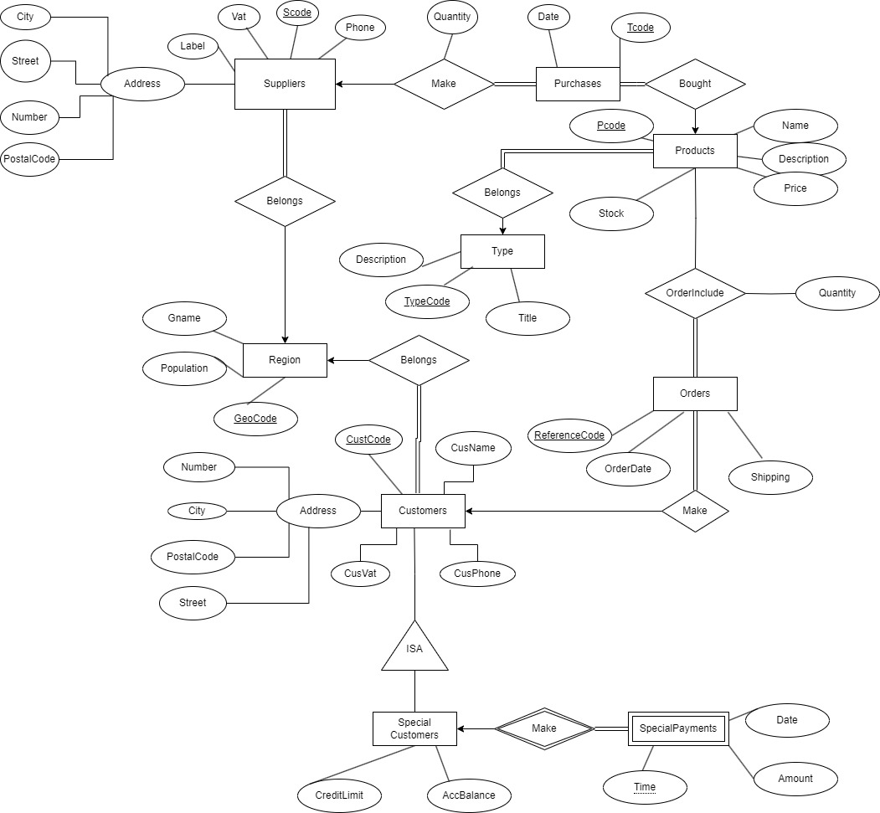

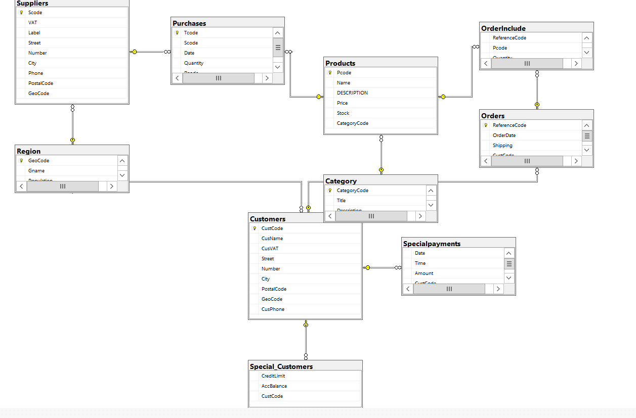

use DB96;
CREATE TABLE Category (
CategoryCode INTEGER NOT NULL,
Title CHAR(30),
Description VARCHAR(300),
PRIMARY KEY (CategoryCode)
);

CREATE TABLE Products (
Pcode INTEGER NOT NULL,
Name VARCHAR(120),
DESCRIPTION VARCHAR(300),
Price DECIMAL(10,2),
Stock INTEGER,
CategoryCode INTEGER NOT NULL FOREIGN KEY REFERENCES Category,
PRIMARY KEY (Pcode)
);

CREATE TABLE Region(
GeoCode INT NOT NULL PRIMARY KEY,
Gname VARCHAR(300),
Population INTEGER
);

CREATE TABLE Suppliers(
Scode INTEGER,
VAT INTEGER,
Label CHAR,
Street VARCHAR(150),
Number INTEGER,
City VARCHAR(30),
Phone BIGINT,
PostalCode INTEGER,
GeoCode INTEGER NOT NULL FOREIGN KEY REFERENCES Region,
PRIMARY KEY (Scode)
);

CREATE TABLE Purchases (
Tcode INTEGER NOT NULL PRIMARY KEY,
Scode INTEGER NOT NULL FOREIGN KEY REFERENCES Suppliers,
Date DATETIME,
Quantity INTEGER NOT NULL,
Pcode INTEGER NOT NULL FOREIGN KEY REFERENCES Products
);

CREATE TABLE Customers(
CustCode INTEGER NOT NULL PRIMARY KEY,
CusName VARCHAR(30),
CusVAT INTEGER,
Street VARCHAR(150),
Number INTEGER,
City VARCHAR(30),
PostalCode INTEGER,
GeoCode INTEGER NOT NULL FOREIGN KEY REFERENCES Region,
CusPhone BIGINT
);

CREATE TABLE Special_Customers(
CreditLimit DECIMAL(10,2),
AccBalance DECIMAL(10,2),
CustCode INTEGER NOT NULL FOREIGN KEY REFERENCES Customers
);

CREATE TABLE Specialpayments(
Date DATE,
Time TIME NOT NULL,
Amount DECIMAL (10,2),
CustCode INTEGER NOT NULL FOREIGN KEY REFERENCES Customers
);

CREATE TABLE Orders(
ReferenceCode INTEGER NOT NULL PRIMARY KEY,
OrderDate DATE,
Shipping DATE,
CustCode INTEGER NOT NULL FOREIGN KEY REFERENCES Customers
);

CREATE TABLE OrderInclude(
ReferenceCode INTEGER NOT NULL FOREIGN KEY REFERENCES Orders,
Pcode INTEGER NOT NULL FOREIGN KEY REFERENCES Products,
Quantity DECIMAL(10,2)
);

use db96
INSERT INTO Category (CategoryCode, Title, Description) VALUES
(20001, 'Electronics', 'Electronic devices'),
(20002, 'Clothing', 'Clothing items'),
(20003, 'Books', 'Books'),
(20004, 'Furniture', 'Furniture items'),
(20005, 'Food', 'Food items');

INSERT INTO Region (GeoCode, Gname, Population) VALUES
(10001, 'RegionA', 10),
(10002, 'RegionB', 20),
(10003, 'RegionC', 30),
(10004, 'RegionD', 40),
(10005, 'RegionE', 50),
(10006, 'RegionF', 60),
(10007, 'RegionG', 70),
(10008, 'RegionH', 80),
(10009, 'RegionI', 90),
(10010, 'RegionJ', 100),
(10011, 'RegionK', 110),
(10012, 'RegionL', 120),
(10013, 'RegionM', 130),
(10014, 'RegionN', 140),
(10015, 'RegionO', 150),
(10016, 'RegionP', 160),
(10017, 'RegionQ', 170),
(10018, 'RegionR', 180),
(10019, 'RegionS', 190),
(10020, 'RegionT', 200);

INSERT INTO Customers (CustCode, CusName, CusVAT, Street, Number, City, PostalCode, GeoCode, CusPhone) VALUES
(50001, 'John Doe', 111222333, 'Main Street', 789, 'CityX', 30000, 10001, 5556667777),
(50002, 'Jane Smith', 444555666, 'Oak Street', 101, 'CityY', 40000, 10002, 8889990000),
(50003, 'Emma Brown', 333444555, 'Pine Road', 234, 'CityA', 31000, 10002, 7778889999),
(50004, 'Oliver Jones', 222333444, 'Birch Lane', 567, 'CityB', 32000, 10001, 6667778888),
(50005, 'Ava Miller', 555666777, 'Maple Ave', 890, 'CityC', 33000, 10002, 5554443333),
(50006, 'William Davis', 666777888, 'Cedar Blvd', 123, 'CityD', 34000, 10001, 4443332222),
(50007, 'Sophia Wilson', 777888999, 'Elm Street', 456, 'CityE', 35000, 10002, 3332221111),
(50008, 'James Taylor', 888999111, 'Willow Path', 789, 'CityF', 36000, 10001, 2221110000),
(50009, 'Isabella Moore', 999111222, 'Holly Drive', 135, 'CityG', 37000, 10002, 1110009998),
(50010, 'Lucas Anderson', 111222344, 'Poplar St', 246, 'CityH', 38000, 10001, 9998887777),
(50011, 'Mia Thomas', 222333455, 'Cherry Road', 357, 'CityI', 39000, 10002, 8887776666),
(50012, 'Ethan Jackson', 333444566, 'Oakridge Lane', 468, 'CityJ', 40000, 10001, 7776665555),
(50013, 'Charlotte White', 444555677, 'Palm Way', 579, 'CityK', 41000, 10002, 6665554444),
(50014, 'Jacob Harris', 555666788, 'Pinecrest Ave', 135, 'CityL', 42000, 10001, 5554443333),
(50015, 'Amelia Martin', 666777899, 'Redwood Circle', 246, 'CityM', 43000, 10002, 4443332222),
(50016, 'Logan Martinez', 777888900, 'Cypress St', 357, 'CityN', 44000, 10003, 3332221111),
(50017, 'Harper Lee', 888999011, 'Aspen Way', 468, 'CityO', 45000, 10002, 2221110000),
(50018, 'Elijah Walker', 999011122, 'Sequoia Blvd', 579, 'CityP', 46000, 10005, 1110009999),
(50019, 'Abigail Hall', 011122233, 'Magnolia Lane', 680, 'CityQ', 47000, 10004, 9998887776),
(50020, 'Alice Johnson', 999888777, 'Maple Street', 303, 'CityZ', 70000, 10001, 3334445555);

INSERT INTO Orders (ReferenceCode, OrderDate, Shipping, CustCode) VALUES
(60049, '2021-03-22', '2021-03-23', 50006),
(60052, '2021-07-30', '2021-07-30', 50003),
(60053, '2021-07-30', '2021-07-30', 50007),
(60054, '2021-07-30', '2021-07-30', 50005),
(60050, '2021-07-30', '2021-07-30', 50003),
(60051, '2021-07-30', '2021-07-30', 50003),
(60046, '2021-07-30', '2021-07-30', 50002),
(60047, '2021-07-30', '2021-07-30', 50003),
(60048, '2021-07-30', '2021-07-30', 50006),
(60040, '2022-05-15', '2022-05-15', 50001),
(60041, '2022-03-15', '2022-03-15', 50004),
(60042, '2022-02-15', '2022-02-15', 50004),
(60043, '2021-06-15', '2021-06-15', 50015),
(60044, '2023-12-15', '2023-12-15', 50017),
(60045, '2022-11-15', '2022-11-15', 50018),
(60001, '2022-06-15', '2022-06-18', 50020),
(60002, '2021-05-10', '2021-05-12', 50002),
(60003, '2021-07-12', '2021-07-13', 50003),
(60004, '2022-01-20', '2022-01-20', 50004),
(60005, '2022-11-05', '2022-11-08', 50005),
(60006, '2021-12-15', '2021-12-16', 50006),
(60007, '2022-03-22', '2022-03-23', 50007),
(60008, '2021-08-30', '2021-08-30', 50008),
(60009, '2022-04-18', '2022-04-19', 50009),
(60010, '2022-02-09', '2022-02-10', 50010),
(60011, '2021-10-13', '2021-10-14', 50011),
(60012, '2022-09-07', '2022-09-08', 50012),
(60013, '2021-03-19', '2021-03-26', 50013),
(60014, '2022-05-21', '2022-05-22', 50014),
(60015, '2022-07-29', '2022-07-29', 50015),
(60016, '2021-04-14', '2021-04-14', 50016),
(60017, '2022-10-16', '2022-10-16', 50017),
(60018, '2021-09-23', '2021-09-25', 50018),
(60019, '2022-08-11', '2022-08-12', 50019),
(60020, '2021-11-30', '2021-11-30', 50020),
(60021, '2022-01-30', '2022-01-30', 50020),
(60022, '2022-02-24', '2022-02-20', 50020),
(60023, '2022-03-30', '2022-03-30', 50020),
(60024, '2022-04-30', '2022-04-30', 50020),
(60025, '2022-05-30', '2022-05-30', 50020),
(60026, '2021-08-30', '2021-08-30', 50002),
(60027, '2021-09-30', '2021-09-30', 50008),
(60028, '2021-10-30', '2021-10-30', 50020),
(60029, '2021-11-30', '2021-11-30', 50002),
(60030, '2021-12-30', '2021-12-30', 50009),
(60031, '2021-01-30', '2021-01-30', 50002),
(60032, '2021-02-20', '2021-02-20', 50020),
(60033, '2021-03-30', '2021-03-30', 50020),
(60034, '2021-04-30', '2021-04-30', 50011),
(60035, '2021-05-30', '2021-05-30', 50001),
(60036, '2021-06-30', '2021-06-30', 50003),
(60037, '2021-07-30', '2021-07-30', 50006),
(60038, '2021-08-30', '2021-08-30', 50008),
(60039, '2021-09-30', '2021-09-30', 50001);

INSERT INTO Products (Pcode, Name, DESCRIPTION, Price, Stock, CategoryCode) VALUES
(30023, 'Laptop', 'High-end gaming laptop', 1200.00, 15, 20001),
(30024, 'T-Shirt', 'Cotton t-shirt', 20.00, 50, 20002),
(30025, 'Smartphone', 'Latest model smartphone', 800.00, 25, 20001),
(30026, 'Backpack', 'Durable travel backpack', 60.00, 30, 20002),
(30027, 'Headphones', 'Noise-cancelling headphones', 150.00, 40, 20001),
(30028, 'Watch', 'Smartwatch with fitness tracker', 250.00, 20, 20001),
(30029, 'Sunglasses', 'Polarized sunglasses', 75.00, 35, 20002),
(30030, 'Jeans', 'Blue denim jeans', 45.00, 60, 20002),
(30031, 'Bluetooth Speaker', 'Portable Bluetooth speaker', 100.00, 40, 20001),
(30032, 'Running Shoes', 'Comfortable running shoes', 85.00, 25, 20002),
(30033, 'Jacket', 'Winter jacket', 150.00, 30, 20002),
(30034, 'Book', 'Bestselling novel', 15.00, 100, 20002),
(30035, 'Tablet', '10-inch tablet', 350.00, 20, 20001),
(30036, 'Gaming Console', 'Latest gaming console', 400.00, 15, 20001),
(30037, 'Camera', 'Digital SLR camera', 550.00, 10, 20001),
(30038, 'Blender', 'Kitchen blender', 90.00, 40, 20001),
(30039, 'Yoga Mat', 'Eco-friendly yoga mat', 30.00, 50, 20002),
(30040, 'Desk Lamp', 'LED desk lamp', 35.00, 45, 20001),
(30041, 'Wireless Keyboard', 'Ergonomic wireless keyboard', 45.00, 30, 20001),
(30042, 'Mouse', 'Wireless mouse', 30.00, 35, 20001),
(30001, 'Laptop', 'High-end gaming laptop', 1200.00, 15, 20001),
(30002, 'T-Shirt', 'Cotton t-shirt', 20.00, 50, 20002),
(30003, 'Smartphone', 'Latest model smartphone', 800.00, 25, 20001),
(30004, 'Backpack', 'Durable travel backpack', 60.00, 30, 20002),
(30005, 'Headphones', 'Noise-cancelling headphones', 150.00, 40, 20001),
(30006, 'Watch', 'Smartwatch with fitness tracker', 250.00, 20, 20001),
(30007, 'Sunglasses', 'Polarized sunglasses', 75.00, 35, 20002),
(30008, 'Jeans', 'Blue denim jeans', 45.00, 60, 20002),
(30009, 'Bluetooth Speaker', 'Portable Bluetooth speaker', 100.00, 40, 20001),
(30010, 'Running Shoes', 'Comfortable running shoes', 85.00, 25, 20002),
(30011, 'Jacket', 'Winter jacket', 150.00, 30, 20002),
(30012, 'Book', 'Bestselling novel', 15.00, 100, 20002),
(30013, 'Tablet', '10-inch tablet', 350.00, 20, 20001),
(30014, 'Gaming Console', 'Latest gaming console', 400.00, 15, 20001),
(30015, 'Camera', 'Digital SLR camera', 550.00, 10, 20001),
(30016, 'Blender', 'Kitchen blender', 90.00, 40, 20001),
(30017, 'Yoga Mat', 'Eco-friendly yoga mat', 30.00, 50, 20002),
(30018, 'Desk Lamp', 'LED desk lamp', 35.00, 45, 20001),
(30019, 'Wireless Keyboard', 'Ergonomic wireless keyboard', 45.00, 30, 20001),
(30020, 'Mouse', 'Wireless mouse', 30.00, 35, 20001),
(30021, 'Socks', 'Cotton socks', 10.00, 100, 20002),
(30022, 'Sweater', 'Cotton sweater', 50.00, 50, 20002);

INSERT INTO OrderInclude (ReferenceCode, Pcode, Quantity) VALUES
(60008, 30014, 1),
(60008, 30012, 1),
(60008, 30011, 1),
(60008, 30010, 1),
(60053, 30005, 3),
(60054, 30006, 5),
(60053, 30005, 3),
(60054, 30006, 5),
(60053, 30015, 3),
(60054, 30016, 5),
(60053, 30005, 3),
(60054, 30006, 5),
(60053, 30005, 3),
(60054, 30006, 5),
(60052, 30008, 1),
(60052, 30003, 1),
(60052, 30007, 1),
(60052, 30004, 1),
(60052, 30004, 1),
(60052, 30004, 1),
(60052, 30004, 1),
(60053, 30005, 3),
(60054, 30006, 5),
(60050, 30001, 2),
(60051, 30002, 2),
(60046, 30001, 1),
(60047, 30001, 1),
(60049, 30001, 4),
(60001, 30001, 1),
(60002, 30002, 2),
(60003, 30003, 3),
(60004, 30004, 4),
(60005, 30005, 5),
(60006, 30006, 6),
(60007, 30007, 7),
(60008, 30008, 8),
(60009, 30009, 9),
(60010, 30010, 10),
(60011, 30011, 4),
(60012, 30012, 1),
(60013, 30013, 2),
(60014, 30014, 1),
(60015, 30015, 1),
(60016, 30016, 1),
(60017, 30017, 1),
(60018, 30018, 2),
(60019, 30019, 2),
(60020, 30020, 1),
(60021, 30021, 4),
(60022, 30022, 2),
(60023, 30001, 1),
(60024, 30002, 1),
(60025, 30003, 2),
(60026, 30004, 3),
(60027, 30005, 3),
(60028, 30006, 3),
(60029, 30007, 1),
(60030, 30008, 1),
(60031, 30009, 1),
(60032, 30010, 1),
(60033, 30011, 2),
(60034, 30012, 2),
(60035, 30013, 3),
(60036, 30014, 3),
(60037, 30015, 4),
(60038, 30016, 1),
(60039, 30017, 2),
(60040, 30018, 1),
(60041, 30019, 5),
(60042, 30004, 5),
(60043, 30002, 4),
(60044, 30001, 1),
(60045, 30001, 1);

INSERT INTO Suppliers (Scode, VAT, Label, Street, Number, City, Phone, PostalCode, GeoCode) VALUES
(40001, 123456789, 'A', '1st Street', 123, 'CityA', 1234567890, 10000, 10001),
(40002, 987654321, 'B', '2nd Street', 456, 'CityB', 9876543210, 20000, 10002),
(40003, 123123123, 'C', '3rd Street', 789, 'CityC', 1231231234, 30000, 10001),
(40004, 456456456, 'D', '4th Street', 101, 'CityD', 4564564567, 40000, 10002),
(40005, 789789789, 'E', '5th Street', 202, 'CityE', 7897897890, 50000, 10001),
(40006, 321321321, 'F', '6th Street', 303, 'CityF', 3213213213, 60000, 10003),
(40007, 654654654, 'G', '7th Street', 404, 'CityG', 6546546546, 70000, 10002),
(40008, 987987987, 'H', '8th Street', 505, 'CityH', 9879879876, 80000, 10001),
(40009, 111222333, 'I', '9th Street', 606, 'CityI', 1112223334, 90000, 10002),
(40010, 444555666, 'J', '10th Street', 707, 'CityJ', 4445556667, 10000, 10001),
(40011, 777888999, 'K', '11th Street', 808, 'CityK', 7778889990, 20000, 10002),
(40012, 000111222, 'L', '12th Street', 909, 'CityL', 0001112223, 30000, 10001),
(40013, 333444555, 'M', '13th Street', 101, 'CityM', 3334445556, 40000, 10002),
(40014, 666777888, 'N', '14th Street', 202, 'CityN', 6667778889, 50000, 10001),
(40015, 999000111, 'O', '15th Street', 303, 'CityO', 9990001112, 60000, 10003),
(40016, 222333444, 'P', '16th Street', 404, 'CityP', 2223334445, 70000, 10002),
(40017, 555666777, 'Q', '17th Street', 505, 'CityQ', 5556667776, 80000, 10001),
(40018, 888999000, 'R', '18th Street', 606, 'CityR', 8889990007, 90000, 10002),
(40019, 222333444, 'S', '19th Street', 707, 'CityS', 2223334448, 10000, 10001),
(40020, 555666777, 'T', '20th Street', 808, 'CityT', 5556667779, 20000, 10002);

INSERT INTO Purchases (Tcode, Scode, Date, Quantity, Pcode) VALUES
(70070, 40008, '2021-05-10', 2, 30002),
(70071, 40009, '2021-05-10', 2, 30002),
(70072, 40010, '2021-05-10', 2, 30002),
(70073, 40011, '2021-05-10', 2, 30002),
(70064, 40006, '2022-06-15', 1, 30001),
(70065, 40005, '2022-06-15', 1, 30001),
(70066, 40003, '2022-06-15', 1, 30001),
(70067, 40004, '2022-06-15', 1, 30001),
(70068, 40002, '2022-06-15', 1, 30001),
(70001, 40001, '2022-06-15', 1, 30001),
(70002, 40002, '2021-05-10', 2, 30002),
(70001, 40001, '2022-06-15', 1, 30001),
(70002, 40002, '2021-05-10', 2, 30002),
(70003, 40003, '2021-07-12', 3, 30003),
(70004, 40004, '2022-01-20', 4, 30004),
(70005, 40005, '2022-11-05', 5, 30005),
(70006, 40006, '2021-12-15', 6, 30006),
(70007, 40001, '2022-03-22', 7, 30007),
(70008, 40002, '2021-08-30', 8, 30008),
(70009, 40003, '2022-04-18', 9, 30009),
(70010, 40004, '2022-02-09', 10, 30010),
(70011, 40005, '2021-10-13', 11, 30011),
(70012, 40006, '2022-09-07', 12, 30012),
(70013, 40001, '2021-03-19', 13, 30013),
(70014, 40002, '2022-05-21', 14, 30014),
(70015, 40003, '2022-07-29', 15, 30015),
(70016, 40004, '2021-04-14', 16, 30016),
(70017, 40005, '2022-10-16', 17, 30017),
(70018, 40006, '2021-09-23', 18, 30018),
(70019, 40001, '2022-08-11', 19, 30019),
(70020, 40002, '2021-11-30', 20, 30020),
(70021, 40003, '2022-01-30', 21, 30021),
(70022, 40004, '2022-02-20', 22, 30022),
(70023, 40005, '2022-03-30', 23, 30001),
(70024, 40006, '2022-04-30', 24, 30002),
(70025, 40001, '2022-05-30', 25, 30003),
(70026, 40002, '2022-06-30', 26, 30001),
(70027, 40003, '2022-07-30', 27, 30003),
(70028, 40004, '2022-08-30', 28, 30003),
(70029, 40005, '2022-09-30', 29, 30003),
(70030, 40006, '2022-10-30', 30, 30003),
(70031, 40001, '2022-11-30', 31, 30003),
(70032, 40002, '2022-12-30', 32, 30011),
(70033, 40003, '2021-01-30', 33, 30012),
(70034, 40004, '2021-02-20', 34, 30012),
(70035, 40005, '2021-03-30', 35, 30011),
(70036, 40006, '2021-04-30', 36, 30012),
(70037, 40001, '2021-05-30', 37, 30012),
(70038, 40002, '2021-06-30', 38, 30012),
(70039, 40003, '2021-07-30', 39, 30012),
(70040, 40004, '2021-08-30', 40, 30012),
(70041, 40005, '2021-09-30', 41, 30019),
(70042, 40006, '2021-10-30', 42, 30020),
(70043, 40001, '2021-11-30', 43, 30020),
(70044, 40002, '2021-12-30', 44, 30020),
(70045, 40003, '2021-01-30', 45, 30020),
(70046, 40004, '2021-02-20', 46, 30020),
(70047, 40005, '2021-03-30', 47, 30003),
(70048, 40006, '2021-04-30', 48, 30004),
(70049, 40001, '2021-05-30', 49, 30005),
(70050, 40002, '2021-06-30', 50, 30006),
(70051, 40003, '2021-07-30', 51, 30007),
(70052, 40004, '2021-08-30', 52, 30008),
(70053, 40005, '2021-09-30', 53, 30009),
(70054, 40006, '2021-10-30', 54, 30010),
(70055, 40001, '2021-11-30', 55, 30011),
(70056, 40002, '2021-12-30', 56, 30012),
(70057, 40003, '2021-01-30', 57, 30013),
(70058, 40004, '2021-02-20', 58, 30014),
(70059, 40005, '2021-03-30', 59, 30015),
(70060, 40006, '2021-04-30', 60, 30016),
(70061, 40001, '2021-05-30', 61, 30017),
(70062, 40002, '2021-06-30', 62, 30018),
(70063, 40003, '2021-07-30', 63, 30019);

INSERT INTO Special_Customers (CreditLimit, AccBalance, CustCode) VALUES
(1000.00, 500.00, 50001),
(2000.00, 1000.00, 50002),
(3000.00, 1500.00, 50003),
(4000.00, 2000.00, 50004),
(5000.00, 2500.00, 50005),
(6000.00, 3000.00, 50006),
(7000.00, 3500.00, 50007),
(8000.00, 4000.00, 50008),
(9000.00, 4500.00, 50009),
(10000.00, 5000.00, 50010),
(11000.00, 5500.00, 50011),
(12000.00, 6000.00, 50012),
(13000.00, 6500.00, 50013),
(14000.00, 7000.00, 50014);

INSERT INTO Specialpayments (Date, Time, Amount, CustCode) VALUES
('2023-01-30', '17:30:00', 2000.00, 50009),
('2023-01-30', '17:30:00', 2300.00, 50009),
('2023-01-30', '17:30:00', 3000.00, 50008),
('2023-01-30', '17:30:00', 500.00, 50009),
('2023-01-30', '17:30:00', 600.00, 50008),
('2023-01-30', '17:30:00', 800.00, 50007),
('2022-01-20', '23:00:00', 140.00, 50014),
('2022-01-20', '23:00:00', 1200.00, 50012),
('2022-05-20', '23:00:00', 140.00, 50014),
('2022-05-18', '22:00:00', 30.00, 50011),
('2022-06-15', '10:00:00', 100.00, 50001),
('2021-05-10', '11:00:00', 200.00, 50002),
('2021-07-12', '12:00:00', 300.00, 50003),
('2022-01-20', '13:00:00', 400.00, 50004),
('2022-11-05', '14:00:00', 500.00, 50005),
('2021-12-15', '15:00:00', 600.00, 50006),
('2022-03-22', '16:00:00', 700.00, 50007),
('2023-01-30', '17:30:00', 800.00, 50008),
('2022-04-18', '18:00:00', 900.00, 50009),
('2023-01-09', '19:00:00', 1000.00, 50010),
('2021-10-13', '20:00:00', 1100.00, 50011),
('2022-09-07', '21:00:00', 1200.00, 50012),
('2021-03-19', '22:00:00', 1300.00, 50013),
('2022-05-21', '23:00:00', 1400.00, 50014),
('2022-07-29', '00:01:00', 1500.00, 50015),
('2021-04-14', '01:00:00', 1600.00, 50016),
('2022-10-16', '02:00:00', 1700.00, 50017),
('2021-09-23', '03:00:00', 1800.00, 50018),
('2022-08-11', '04:00:00', 1900.00, 50019),
('2021-11-30', '05:00:00', 2000.00, 50020);

